**Graph of magnetic force F depending on the current flowing in the frame I(A):**

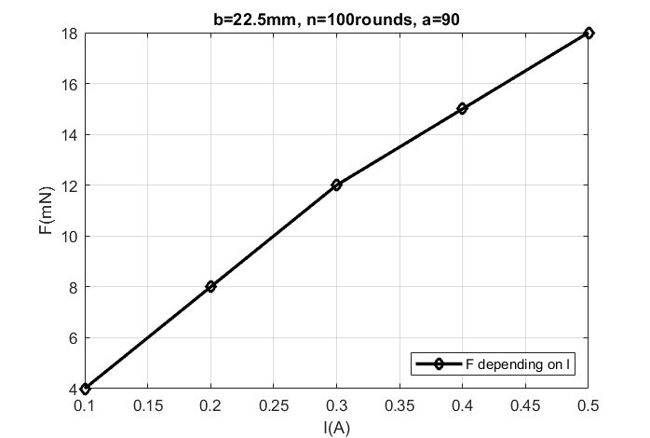

Figure 1: F depending on I

**Graph of the magnetic force F depending on the angle $α$ between I.L and B:**

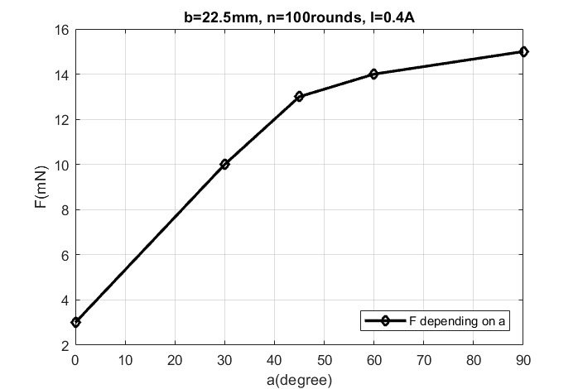

Figure 2: F depending on the angle α

**Graph of the magnetic force F depending on the length of the current b:**

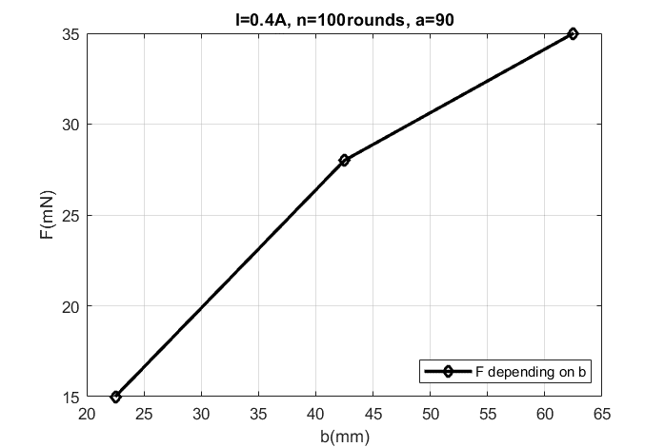

Figure 3: F depending on the length of current b